Chapter 6, Problem 69.

An op amp integrator with R = 4 MΩ and C = 1 μF has the input waveform shown in Fig. 6.88. Plot the output waveform.

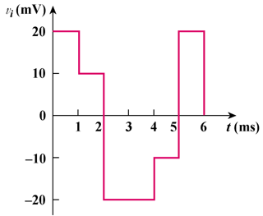

Figure 6.88
For Prob. 6.69.

